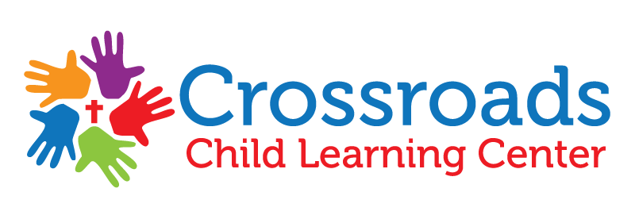
Sunscreen Choice

My child, ________________________________, has permission to use the sunscreen provided by Crossroads Child Learning Center.

OR

My child, _______________________________, does NOT have permission to use the sunscreen provided by Crossroads Child Learning and I will provide sunscreen for my child.

__________________________________ _______________
Parent/Guardian Signature Date

