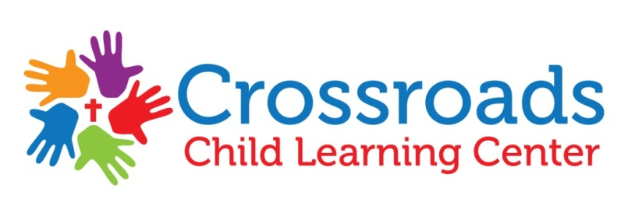
Parents/Guardians,
We at Crossroads Child Learning Center know how hectic life can get and we want to make bringing your children here as hassle free as possible. To make this happen, we will be providing Cuties Care® all inclusive diapers, wipes and training pants program! For a small cost of $7.00 a week for full-time enrolled children and $4.00 a week for part-time (3 or less days a week) children all your diapers and wipes will be provided here at the center. No more worrying if you forgot to pack the diapers before heading to work! We have sample packets of diapers for you to try! Just let us know what size you need.
Whether or not you would like to utilize the diaper program, please complete the form at the bottom of this letter. Keep in mind that if you forget to provide diapers and wipes for your child more than two times, your child will automatically be enrolled in the program.
Once you feel that your child will be potty-training and will no longer need the program or you do not wish to continue with the program you are required to give at least a two weeks notice to office staff.
You may also be interested in enrolling in the Cuties Express Home Supply and Savings Club! Enjoy the wonderful convenience of never having to run to the store and wait in long lines for diapers, wipes and training pants again. Sign up for the Cuties Express program, and month we will have your supplies ready for pick up when you come to get your child.

If you have any questions or concerns, please contact Shelbie Eshleman at (570)923-7285.
Thank you!
--------------------------------------------------------------------------------------------------------------------------------------------------------------
Child(ren)’s Name:______________________________________________________________________
⃝ YES, I would like my child(ren) enrolled in the Cuties Diaper Program
- I understand that my account will be charged weekly for the use of this program and that I must give at least a two weeks notice if I wish to withdraw from the diaper program.

Diaper/Training Pants Size________
Full Time ($7.00/week)_____ Part Time-3 or less days a week($4.00/week)_____

⃝ NO, I would not like my child(ren) enrolled in the Cuties Diaper Program
- I understand that if I fail to provide diapers or wipes for my child more than two times, I will automatically be enrolled in the diaper program and be charged accordingly.

Parent/Guardian Signature________________________________________________ Date_____________

